|  |  |
| --- | --- |
| **NAMA**  **NIM**  **KELAS**  **MATKUL** | **: HENDRA USMAN**  **: D0221079**  **: F INFORMATIKA**  **: INTERAKSI MANUSIA DAN KOMPUTER** |

* **CV ASLI**

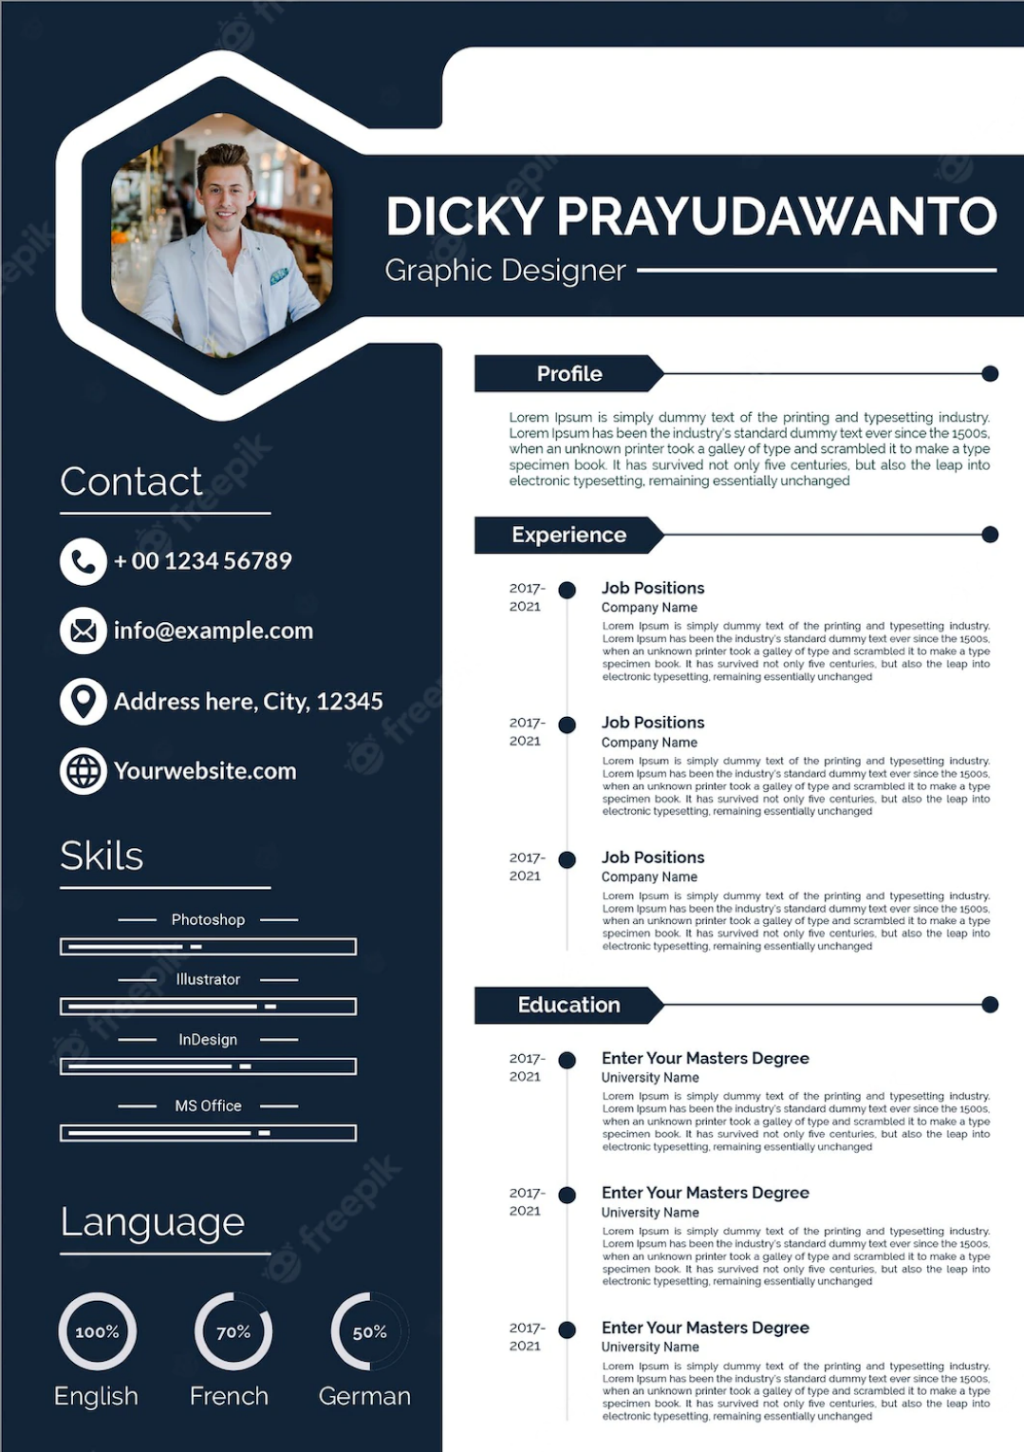

* **PROSES RE-DESAIN CV**

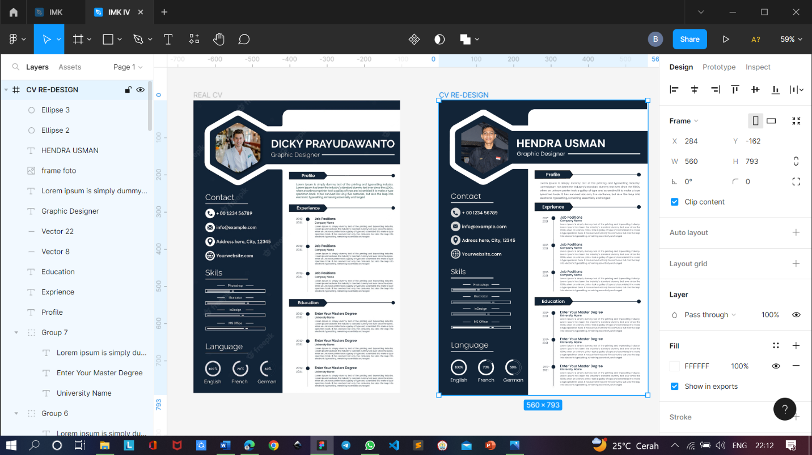

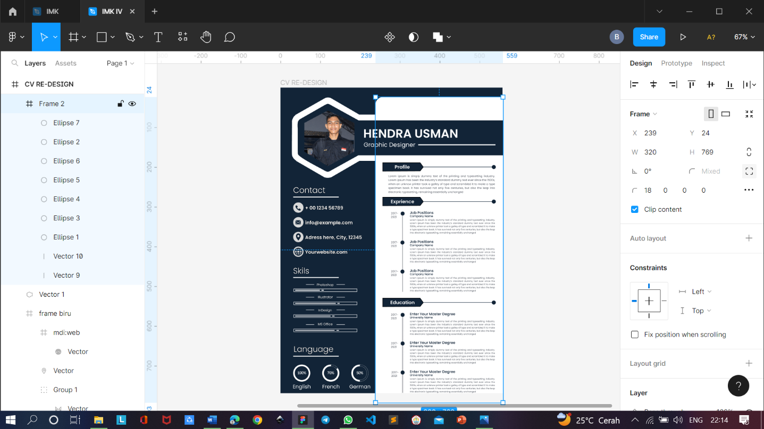

* **CV HASIL RE-DESAIN**

